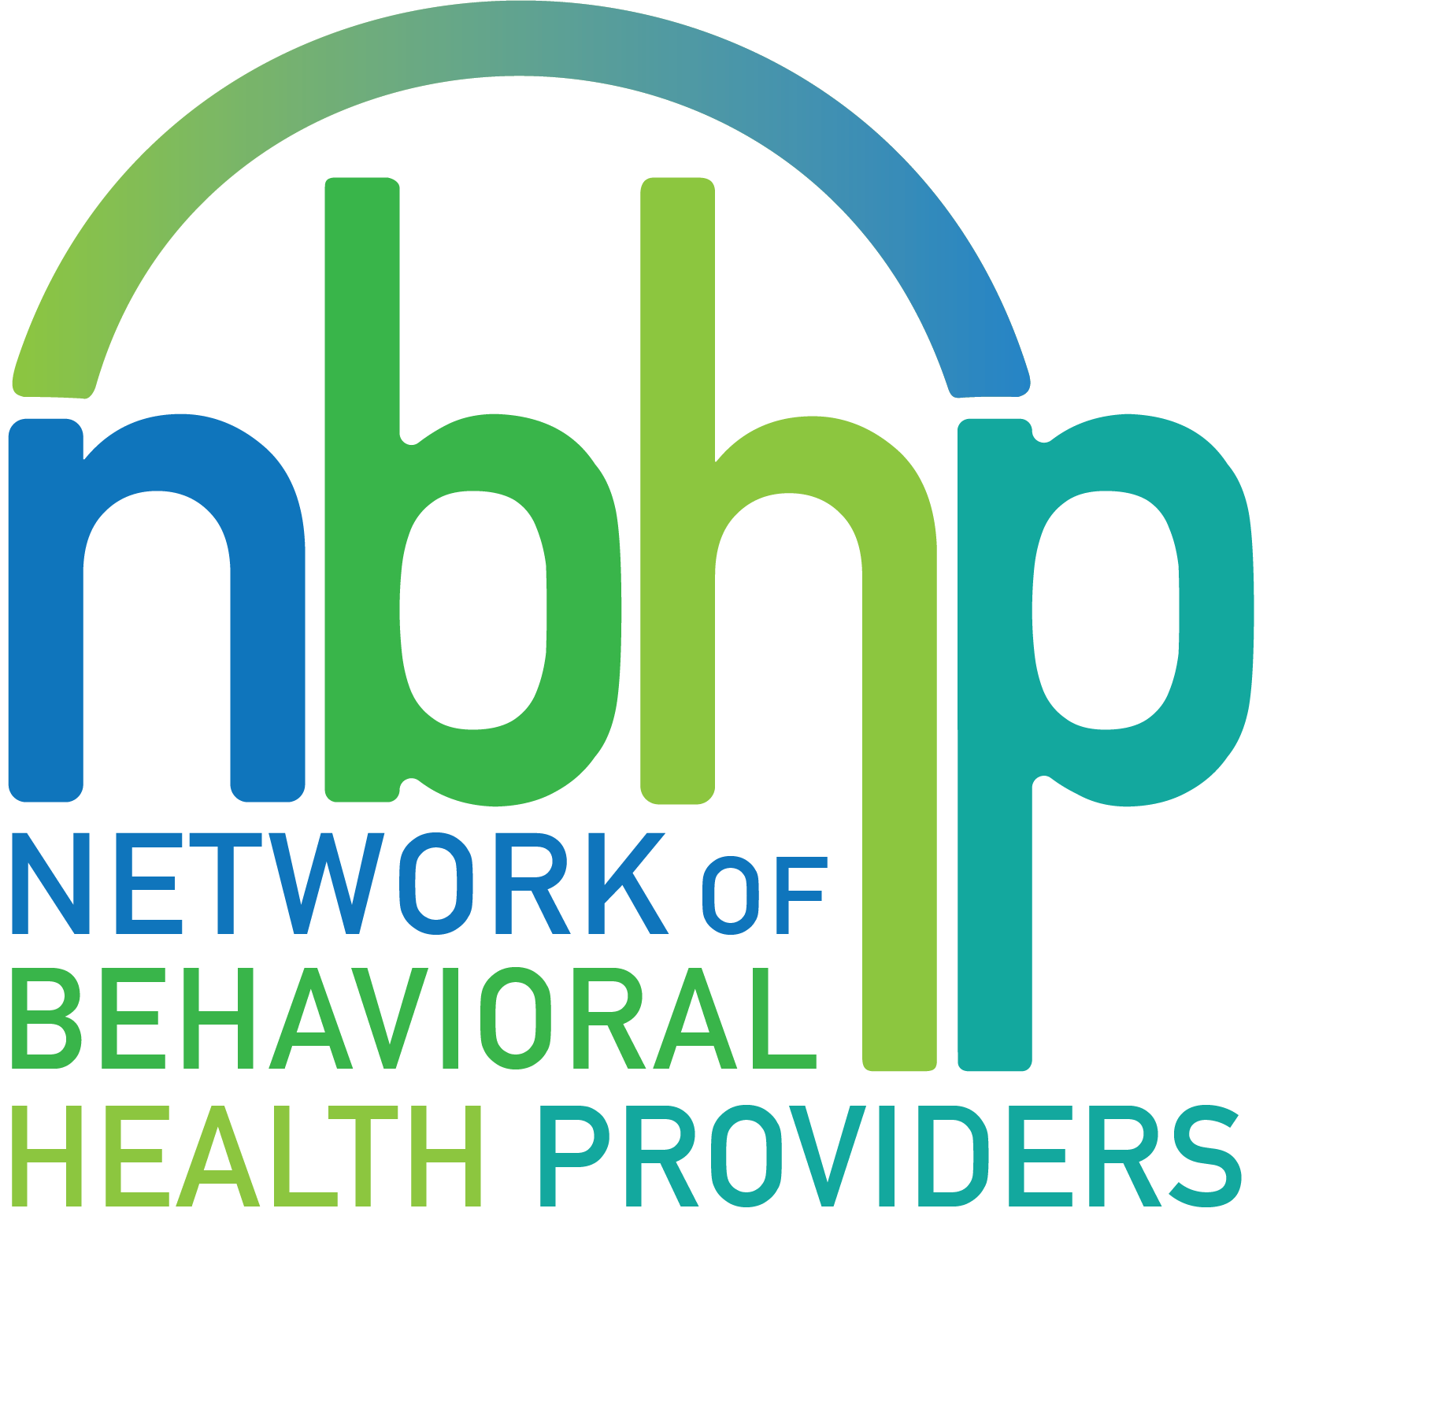
NBHP Membership Overview

Members are offered an outstanding array of benefits that derive from its mission. The Network will:

- Protect and preserve the capability of member organizations to effectively provide a comprehensive program of high-quality, professionally administered behavioral health services to all persons in need of care;

- Serve as a forum for the sharing and exchange of information, ideas, problems, and solutions in areas of mutual interest and concern to members;

- Represent the members’ perspective to public policy decision-makers and influence the development or modification of public policy in the interest of improving the behavioral health system in the Greater Houston area and throughout Texas;

- Develop and administer shared projects to benefit member organizations; and

- Plan and implement programs that advocate for people in need of mental health and/or substance use disorder services and improve the general public’s awareness and understanding of behavioral health issues.

Exclusive Membership Benefits Include

Through our collective membership, NBHP has developed programs that provide resources and benefits to our member organizations and the surrounding communities:

- The Workforce, Recruitment, Education, and Development Initiative (WREDI) focuses on increasing a culturally and linguistically diverse workforce and increasing opportunities for access to BH care.

- Additionally, The Pathways Community HUB program has provided grant opportunities for specific programming within our member organizations to become Community Care Agencies.

- Collective Grant Award resulting in 22 organizations receiving $1.2 Million in employee retention, recruitment, and education stipends.

- Monthly Membership Meetings offering
  - Networking opportunities
  - Relationship building and comradery
  - Resource sharing
  - Information sharing among colleagues
  - Collaborative projects and referral opportunities
  - Informal sources of assistance with/advice on service challenges
  - Formal presentations from key leaders in a small group setting
  - Informational presentations
- Annual Celebration and Awards Event

- Leadership opportunities to serve on the Board of Directors
  - Officers and Committee Chairs

- Opportunities to participate in several committees:
  - Governance
  - Membership
  - Finance
  - Public Policy
  - Projects
  - Development

- A Voice for collective advocacy
  - Access to a strong government relations staff for policy information and advocacy formation on behalf of the Network
  - Being part of an advocacy voice representing 45+ behavioral health providers
  - Vehicle to take individual agency policy challenges to a higher level
  - Legislative Session education
  - Weekly Bill tracking during legislative session
  - Organization of collective event at Capital during legislative session

- Collaborative projects to address shared needs
  - WREDI Externship Site Opportunities and Potential Hires
  - Table opportunities at NBHP Internship and Practicum Fairs
  - Quarterly Behavioral Health Roundtable

- Free Monthly CEU Training opportunities on relevant behavioral health issues for organization staff (Licensed Clinicians, Designated Supervisors, LCDC, Peer Specialists, CHWs, Licensed Psychologists)

- NBHP Member Promotional Opportunities
  - Website Community Job Board - Share job posting
  - Website Training Activities and CEU Advertising and links
  - Website and Social Media Announcements

- Emergency Behavioral Health Response Registry and PFA Training Collaboration with The Harris Center, City of Houston and Harris County Health and Human Services

- Bi-Yearly NBHP Newsletter

Membership Dues Structure

Behavioral Health Organization Dues are based on the organization's overall budget.

Larger Health Based or Academic Organizations to determine budget based on behavioral health services provided. Please use the attached list of behavioral health services when determining BH budget including staff salary and benefits.

2023 Membership Dues
Annual Behavioral Health Budget | Dues | Status
< $500,000 | $600 | Unchanged
$500,000 to $1,000,000 | $1,100 | Unchanged
$1,000,000 to $5,000,000 | $1,600 | Unchanged
$5,000,000 to $10,000,000 | $2,200 | Unchanged
$10,000,000 to $25,000,000 | $3,500 | Tier Added
$25,000,000 > | $5,000 | Tier Added

Organization Name:
Organization Representative:
Organization Annual Behavioral Health Budget:
2023 Annual Membership Dues:

